Landscape & Irrigation System Monthly Service Report

Client | Khazna Data Center | Facilities Management | ---
Location | Khazna Data Center – Meydan, DXB | JOB CODE | 022901/22A10501
Service Provided | Landscape & Irrigation Maintenance | Month | August 2026

ANNUAL PROACTIVE PLAN MAINTENANCE
Activities | Frequency | Jan. | Feb. | Mar. | April | May | June | July | Aug. | Sep. | Oct. | Nov. | Dec.
General cleaning/Removal of debris | Weekly Twice | ● | ● | ● | ● | ● | ● | ● | ● | ● | ● | ● | ●
Checking of water availability | Weekly Twice | ● | ● | ● | ● | ● | ● | ● | ● | ● | ● | ●
Hand-watering of Pots | Weekly Twice | ● | ● | ● | ● | ● | ● | ● | ● | ● | ● | ●
Pruning Shrubs & Hedges | Monthly | ● | ● | ● | ● | ● | ● | ● | ● | ● | ● | ● | ●
Pruning Groundcovers | Monthly | ● | ● | ● | ● | ● | ● | ● | ● | ● | ● | ● | ●
Weeding | Monthly | ● | ● | ● | ● | ● | ● | ● | ● | ● | ● | ● | ●
Soil Cultivation | Monthly | ● | ● | ● | ● | ● | ● | ● | ● | ● | ● | ● | ●
Trees (Crown Thinning, cleaning) | Bi-Monthly | ● |  | ● |  | ● |  | ● |  | ● |  | ●
Fertilization | Quarterly |  | ● |  |  | ● |  |  |  | ● |  | ●
Irrigation Maintenance | Quarterly | ● |  |  | ● |  |  | ● |  |  | ●
Irrigation Controller timing change | Quarterly |  |  |  | ● |  |  |  | ● |  |  | ●
Agriculture Pest Control | Half Yearly + As required |  |  |  | ● |  |  |  |  | ●
Trees (Crown Reduction) Hard-Pruning | Annual |  |  |  |  |  |  |  |  |  |  |  | ●

OPERATIONS PERFORMANCE
PPM TASKS Carried-out during the Month:
Activity | Frequency | Complete (✓) | Pending (✗) | Remarks
General cleaning/Removal of debris | Weekly Twice | ✓ |  | Every Monday & Saturday
Checking of water availability | Weekly Twice | ✓ |  | Every Monday & Saturday
Hand-watering of Pots | Weekly Twice | ✓
Pruning Shrubs & Hedges | Monthly | ✓ |  | Pruning of shrubs and Groundcovers maintain shape, density, and overall plant health.
Pruning Groundcovers | Monthly | ✓
Weeding | Monthly | ✓
Soil Cultivation | Weekly | ✓ |  | Soil loosened to improve aeration and drainage.
Irrigation Controller timing change | Quarterly | ✓ |  | Adjustment of irrigation controller timings to optimize irrigation scheduling based on seasonal plant water requirements.

Irrigation Water Meter Consumption Log

Month | January 2026 | Feb 2026 | March 2026 | April 2026 | May 2026 | June 2026 | July 2026 | August 2026 | Sept 2026 | Oct 2026 | Nov 2026 | Dec 2026
Total Monthly Consumption (m3) | - | - | - | - | - | - | - | 788.24 m3

EXTRA OR PENDING TASKS Carried-out during the Month:
S/N | Description
01 | Installation of shade netting around the Ficus nitida trees located in front of the Pods to provide protection from excessive solar exposure and high summer temperatures.
02 | Application of Desert Energy NPK Fertilizer (12-12-17 + 2MgO + TE) for Delonix trees to enhance nutrient availability.

REACTIVE MAINTENANCE TASKS Carried-out during the Month:
S/N | Description
01 | Trimming Infront the Pods from POD 6 to POD 2 carried out
02 | Ficus nitida and Clerodendrum inerme are showing leaf scorching and burning symptoms, which are primarily attributed to the high summer temperatures, intense solar radiation, and harsh climatic conditions prevailing during the summer period  The affected plants are expected to gradually recover as temperatures decrease and climatic conditions become more favorable.
03 | Dry Sesuvium plants were removed, and healthy plant cuttings will be propagated and replanted once ambient temperatures reduce to more favourable levels, supporting successful establishment and reducing heat stress.

OPERATIONAL CONSTRAINS
S/N | Incident Description | Status
01 | A Detailed Condition Survey Report has been submitted to Client along with the necessary replacement proposal for Review and approval with ref.no. 06-2026-04775 dated 30.06.2026 | Open
02 | A proposal has been shared to Client for Irrigation rectification to make the Irrigation system Automatic and suitable for regular operationsRef.no #9979 & Ref.no. #9978 | Open: Recommend to rectify the irrigation system

OPERATIONS CONTACT DETAILS
Role | Name | Phone | Email
Project Engineer | Renin Amaldass | 052 848 0153 | renin@italianplanters.com
Operations Coordinator | Ebin Shiji | 052 848 0151 | operations@italianplanters.com

OSH TRAINING
- Emergency rescue plan
- COSHH & spillage procedure
- Fire Safety
- Common falling object

PHOTOGRAPHS
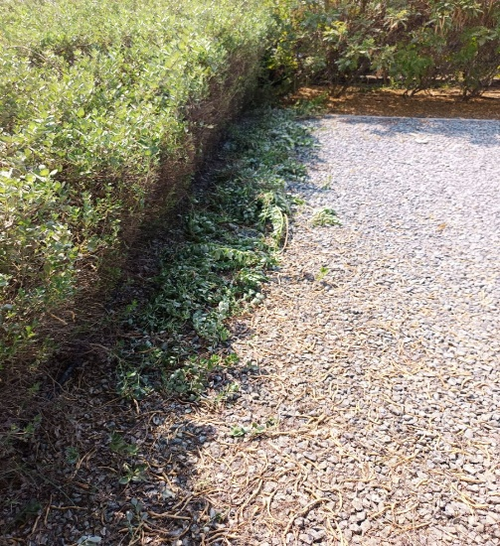 | 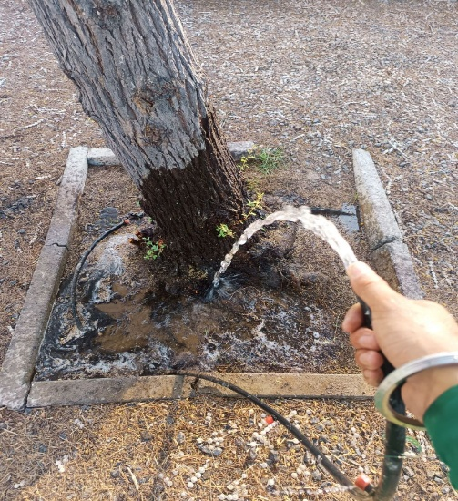 | 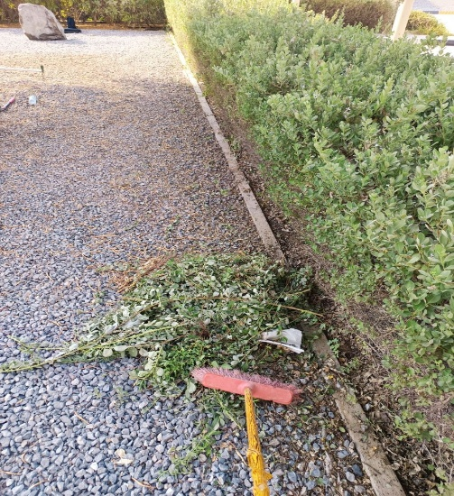
Removal of weeds | Manual Watering | Removal of weeds
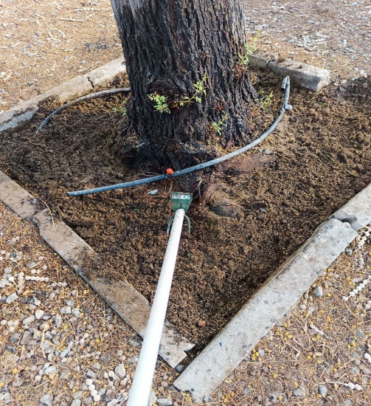 | 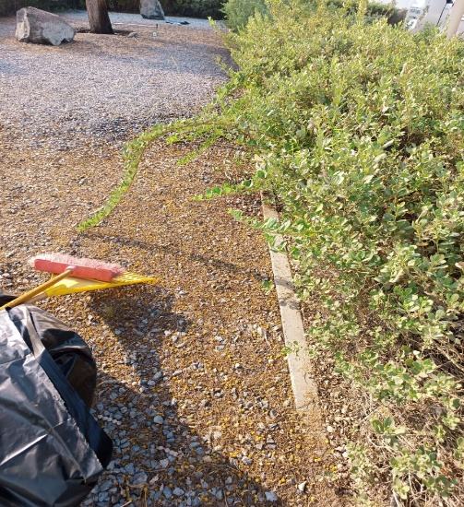 | 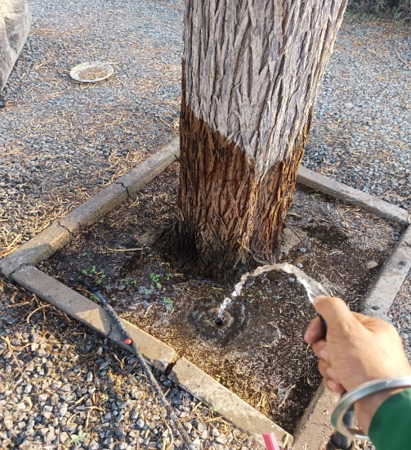
Soil Cultivation | Cleaning and Removal of Fallen Dry Leaves | Manual Watering
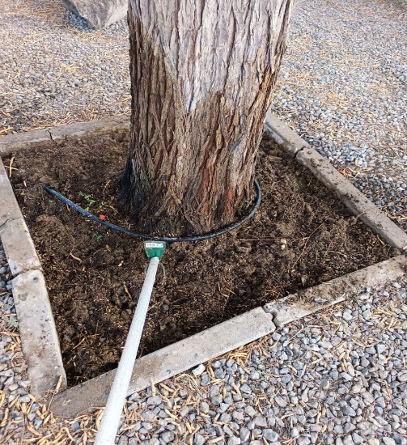 | 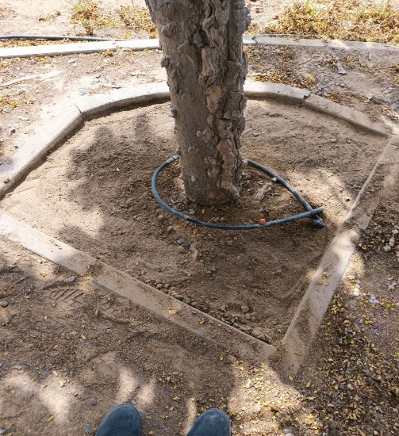 | 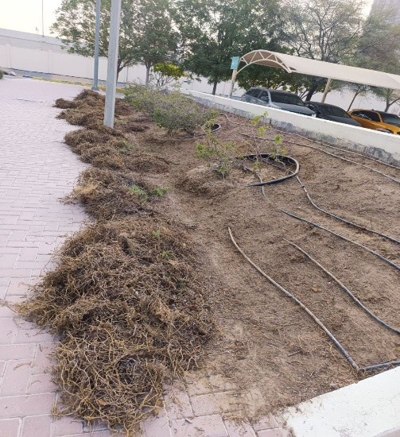
Soil Cultivation | Cleaning and Removal of Fallen Dry Leaves | Removal of Dry plants infront of the pods

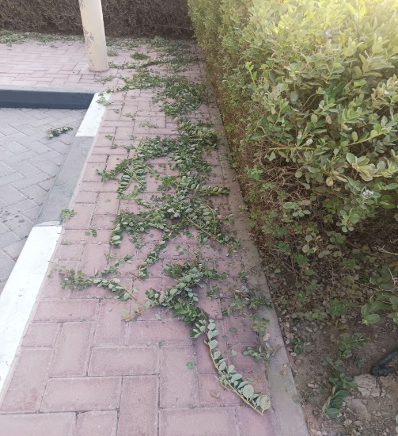 | 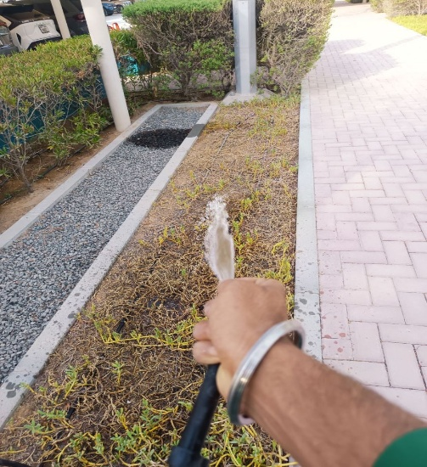 | 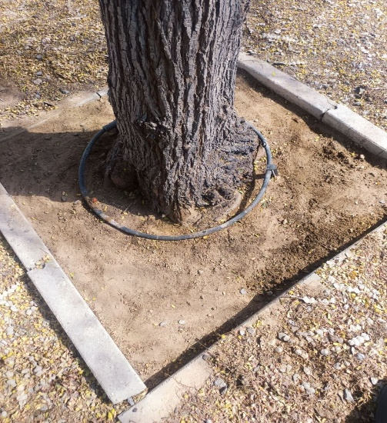
Trimming Activity | Manual Watering | Cleaning and Removal of Fallen Dry Leaves
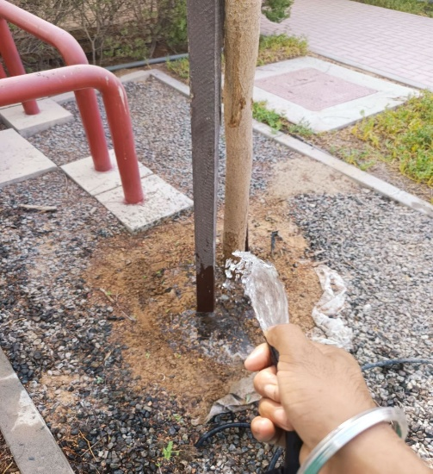 | 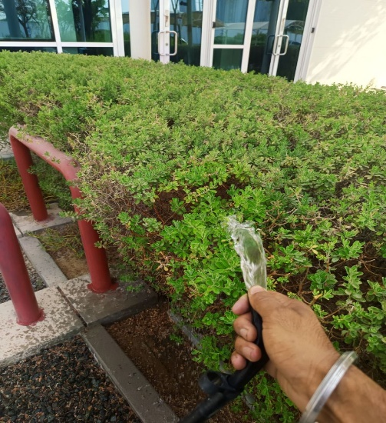 | 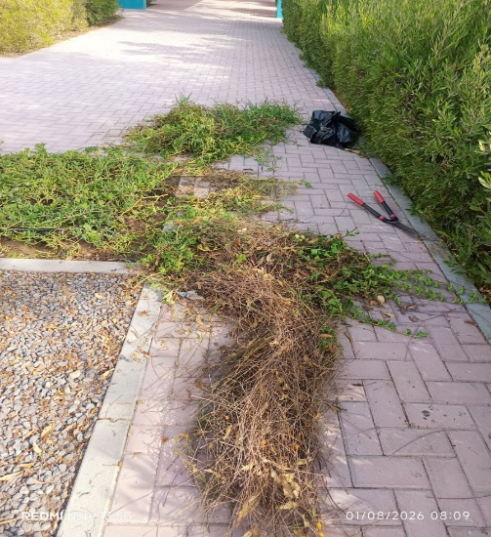
Manual Watering | Manual Watering | Trimming Activity
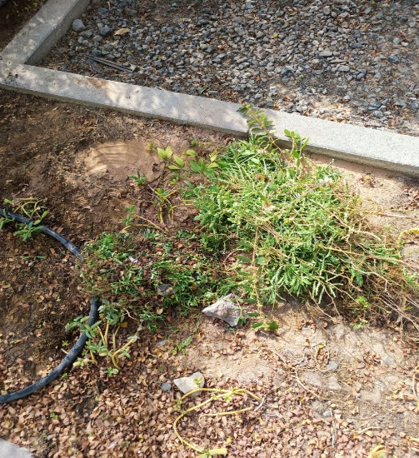 | 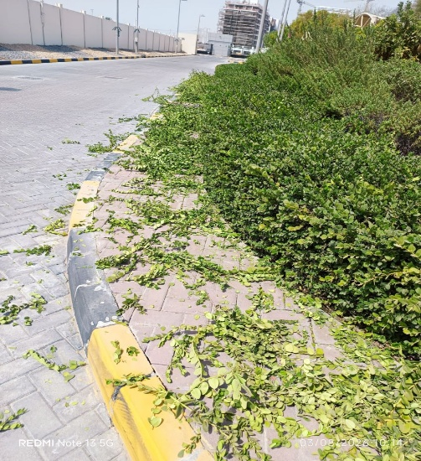 | 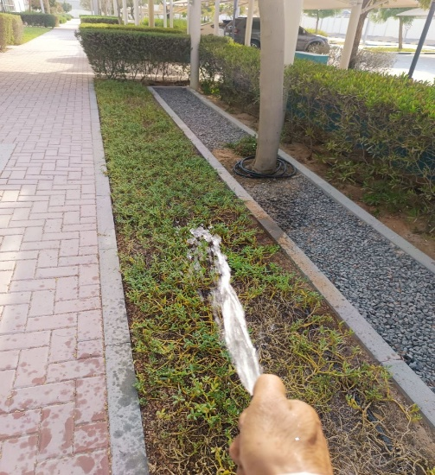
Removal of weeds | Trimming Activity | Manual Watering

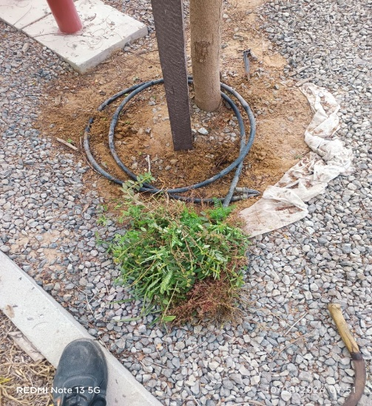 | 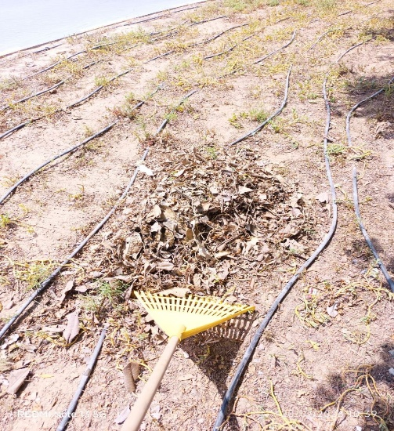 | 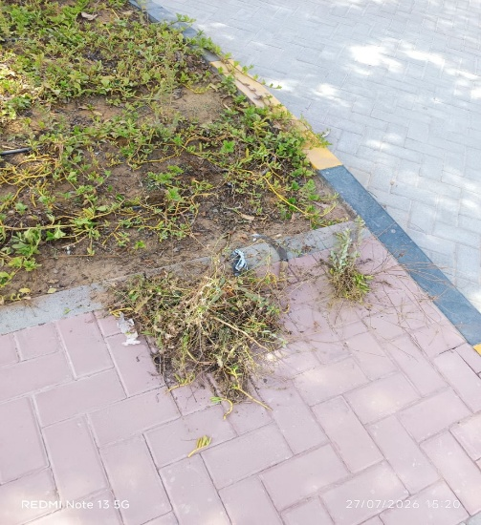
Removal of weeds | Cleaning and Removal of Fallen Dry Leaves | Weeding
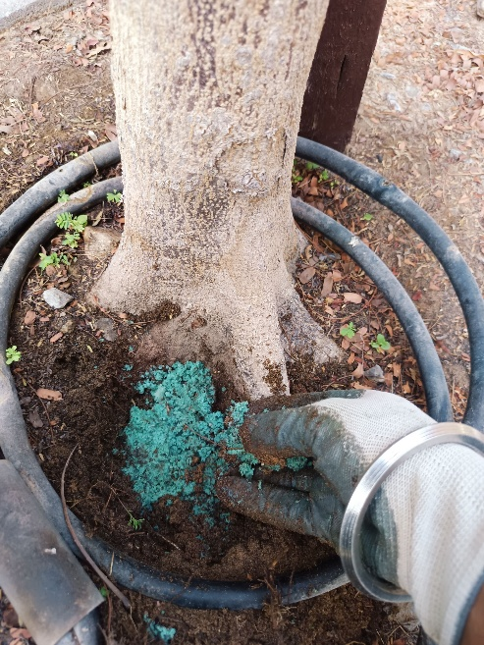 | 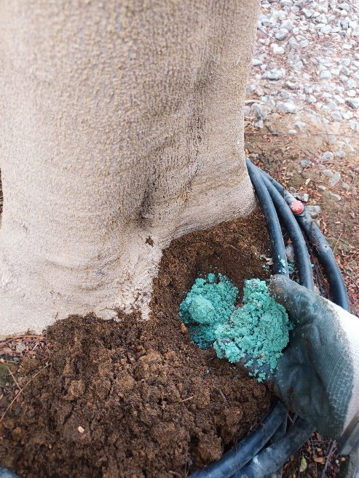 | 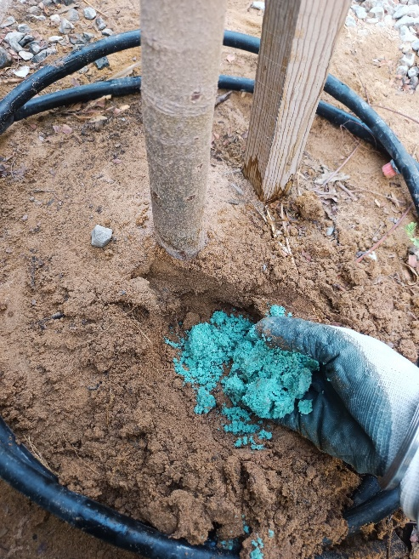
application of npk fertilizer | application of npk fertilizer | application of npk fertilizer
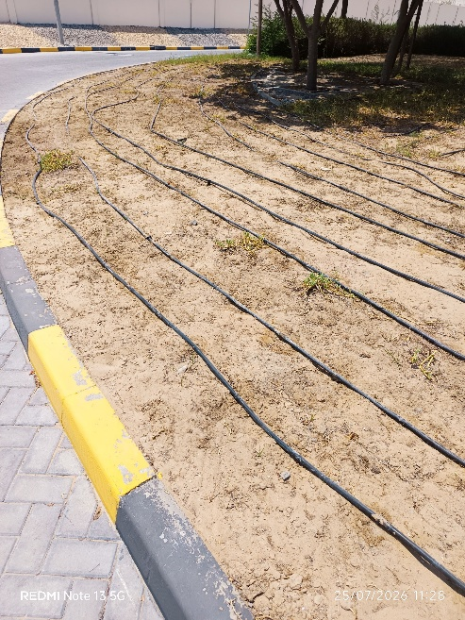 | 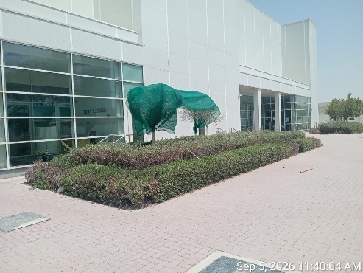 | 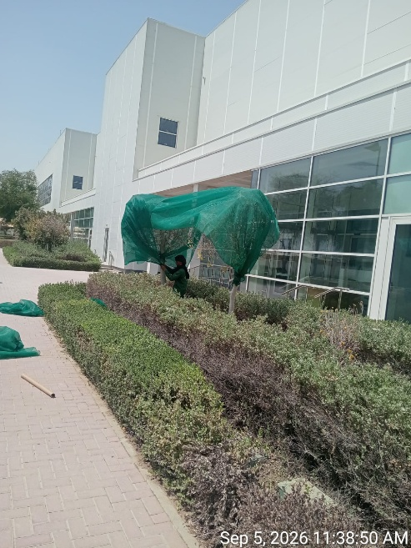
Removal of dry plants | installation of green net | installation of green net

Agriculture Engineer | Basem Adel
Date | September 5, 2026

